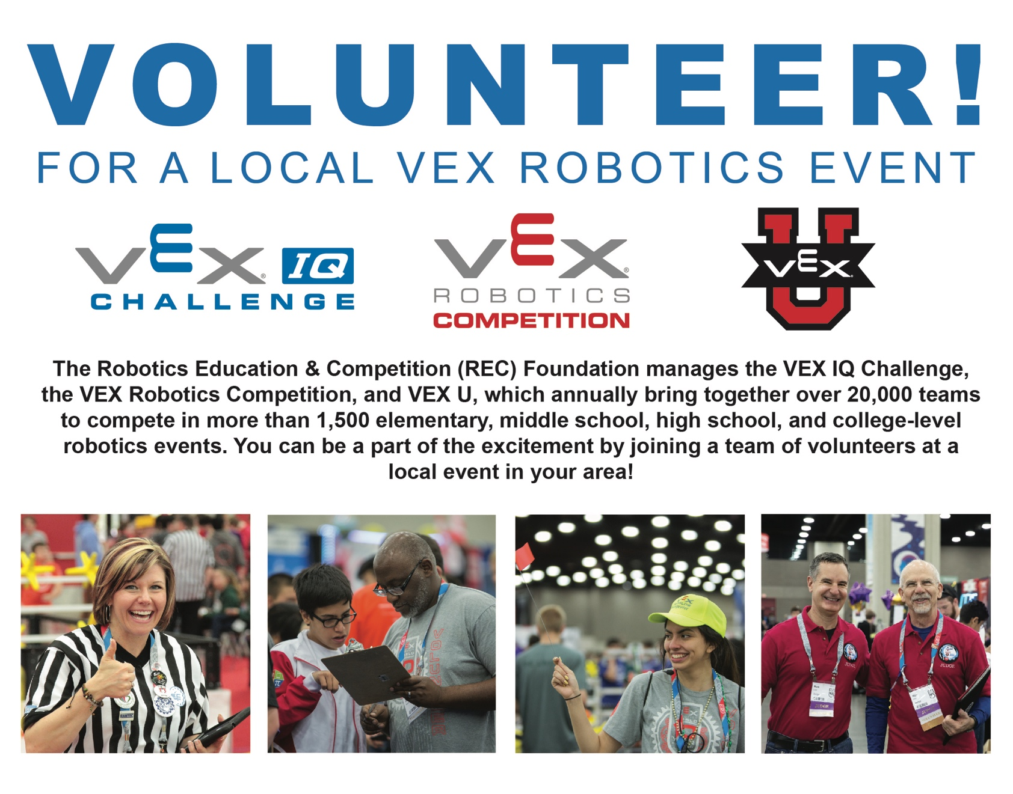

Event Name: VEX Robotics CA State Championship
Event URL: https://www.robotevents.com/robot-competitions/vex-robotics-competition/RE-VRC-17-4576.html
When: Friday, February 23-25, 2018.
Where: Pomona Fair Grounds
Volunteers Needed: Technical Non-Technical
Robot Inspectors Volunteer Check In
Referees Team Check In
Judges Team Queuing
Tournament Manager Operator Field Reset
Event Setup
Additional Information:
We will have VRC High School playing on Saturday Feb 24th along with Middle School IQ teams. Middle School VRC team will play on Sunday Feb 25th along with Elementary IQ teams.

Contact: Nancy McIntyre nancy_mcintyre@roboticseducation.org
For more information about the REC Foundation visit www.RoboticsEducation.org

